11.7: If the board is taken to be massless, the weight of the motor is the sum of the applied forces, 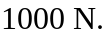 The motor is a distance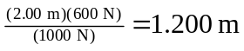from the end where the 400-N force is applied.

